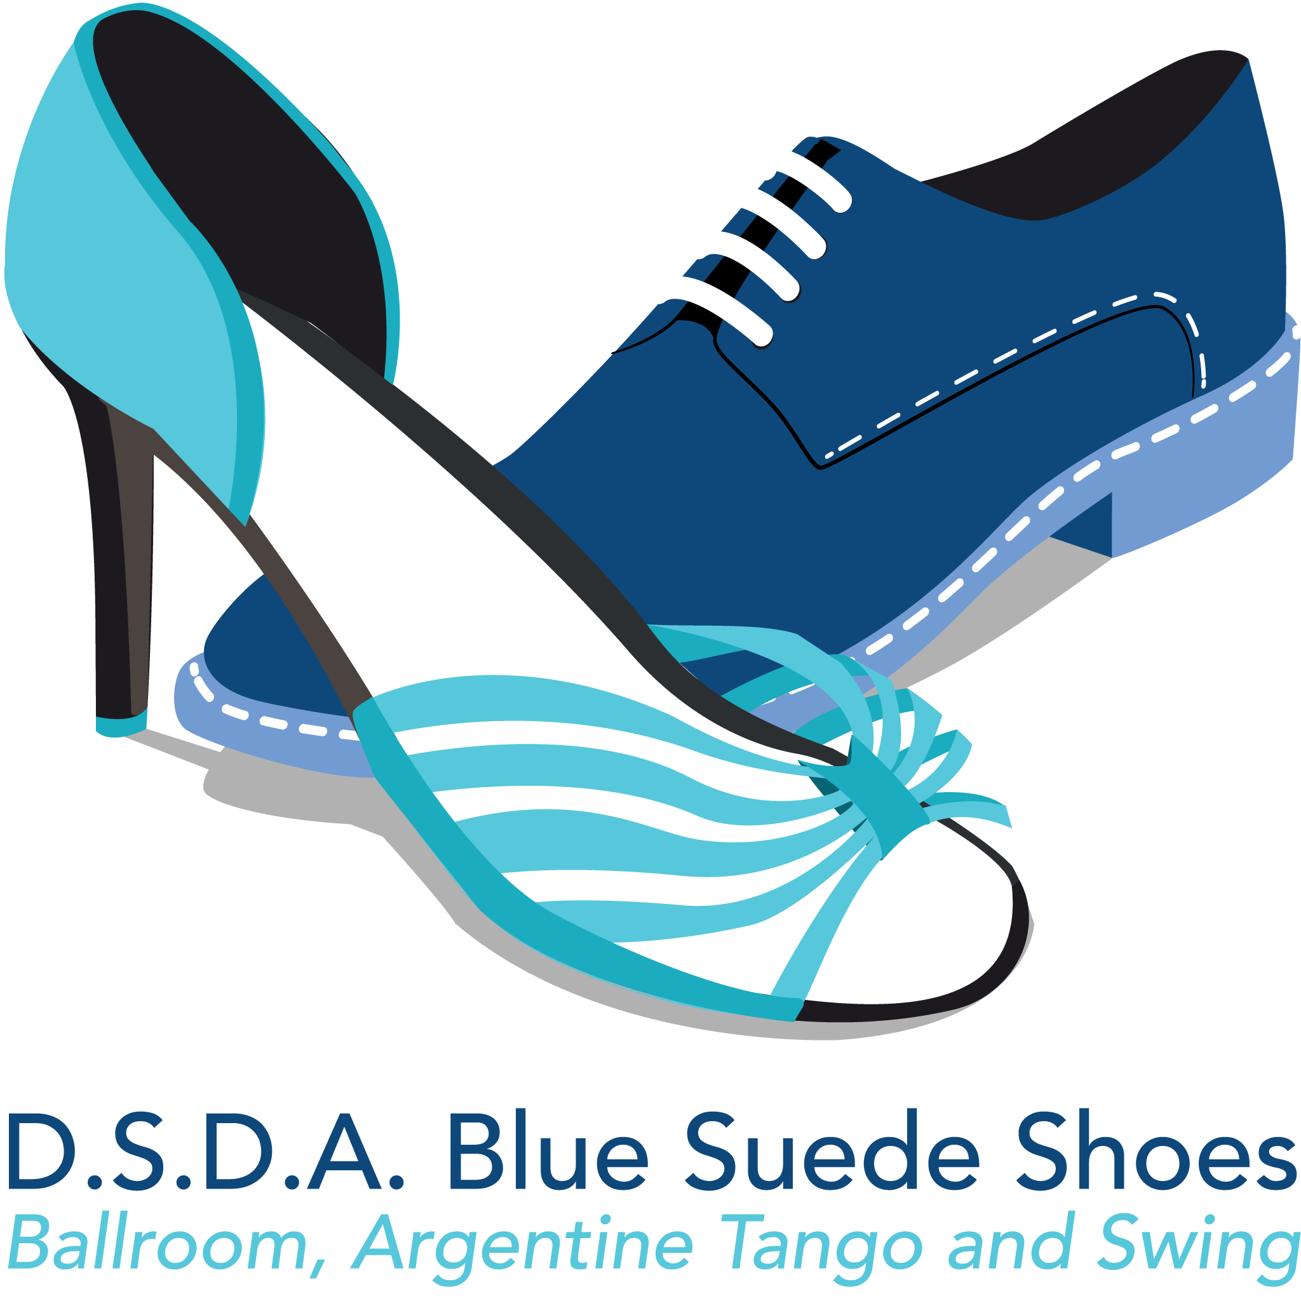
Delft Student Dance Association Blue Suede Shoes
Membership form 23-24
Yes, I would like to join D.S.D.A. Blue Suede Shoes.

Personal details
First name _________________________________________________________
Last name _________________________________________ Initials __________
E-mail address ______________________________________________________
Date of birth ______________ Phone number ____________________________
I’m interested in:
☐ Ballroom (Latin and/or Standard)
☐ Argentine Tango
☐ Lindy Hop
Socials:
We use different methods of getting information about events and the association to our members. Everyone gets the newsletter and the website contains all information.
We also recommend joining the WhatsApp group for staying up to date and Facebook group for events.

☐ Add me to the Blue Suede Shoes WhatsApp group
☐ Add me to the members Facebook group

Membership type
Blue Suede Shoes offers different membership types based on your current situation.
☐ General – Student or non-student excluding X-card
Excluding X-Card
☐ Year membership € 70.00
☐ Semester membership* € 35.00
☐ Student – Bachelor or Master from any university, or TU Delft PhD
Including X-Card
☐ Year membership € 105.00
☐ Semester membership* € 52.50
☐ TU Delft Alumni and Employees
Including X-Card
☐ Year membership € 129.00
☐ Semester membership* € 64.50
☐ TU Delft Alumni and Employees
With X-association-subscription, no X-card
☐ Year membership € 105.00
☐ Other (incl. PhDs from other universities)
With X-association-subscription, no X-card
☐ Year membership € 105.00

* A semester membership can only be selected if you want to become a member for the second semester, or if you can only be a member for half a year, e.g. for exchange students.

If applicable, reason for half yearly membership: _________________________________________

Your membership will automatically be extended for a full year unless you cancel your membership. This can be done by sending an email to the Board: info@dsda.nl. Please take into consideration the unsubscription date indicated in Appendix A.
If you are leaving for a semester abroad or would like to temporarily unsubscribe for some other reason, please simply email info@dsda.nl about this matter, to provide a written proof of temporary unsubscription to the board.

X-card
This question only applies if you do not choose the “General” membership type. Some membership types include either an X-association-subscription or a full X-card. If you already have an X-card for 2023-2024, this reduces the yearly membership fee to €25.50 for students and €48.50 for non-students.
Do you already have an X-card?
☐ No ☐ Yes, I got it by ___________________________________
Are you currently affiliated with TU Delft, Hogeschool InHolland or the Haagse Hogeschool (student, employee, or similar; not including alumni)?
☐ No ☐ Yes

Payment options
☐ Automatic Incasso (recommended)
I hereby authorize DSDA Blue Suede Shoes to collect the membership fee corresponding to my membership type from my account until my denunciation of termination (Appendix A).

IBAN ____________________________________________________________
Owner of bank account _____________________________________________
City of bank ______________________________________________________
☐ Manual Bank Transfer
Bank details:
Vereniging DSDA Blue Suede Shoes
NL97 INGB 0007 488614
Description: “Your name” + Membership reference code

Membership reference code:
Full year Semester
Student: BSS-M1F BSS-M1S
Alumni (X-card): BSS-M2F BSS-M2S
Alumni (BSS-card): BSS-M3F BSS-M3S
General: BSS-M4F BSS-M4S
Other: BSS-M5F BSS-M5S

The signature
You can find our privacy statement, by-laws, and articles on our website: www.dsda.nl
Confirmation of terms and conditions:

☐ I have read and understand the terms of agreement concerning the member fee.

Date _______________________________
Signature new member Signature Blue Suede Shoes
.. .. .. .. .. .. .. .. .. .. .. .. .. .. .. .. .. .. .. .. .. .. .. .. ..

Welcome to

APPENDIX A
Goals of DSDA Blue Suede Shoes
It is the goal of DSDA Blue Suede Shoes to be an Association for everyone passionate about dancing. We also want to give people a platform to express and develop their creativity as well as advance their skills by facilitating practices and guest teachers. We also want to give our members the opportunity to socialise with other like minded dancers by facilitating parties and monthly meeting/dance gatherings.

Activities DSDA Blue Suede Shoes
DSDA Blue Suede Shoes has the ambition to offer great activities for their dancing members. Below you will find the activities which are offered currently. New activities might be added in the future by the board or committees.
Currently, the following activities will be offered:
- DSDA Blue Suede Shoes hangouts. Members can meet once or twice a month at a social event with different activities.
- Free hour(s) a week for dance practice
- Technique classes for all different dance styles.
- DSDA Blue Suede Shoes parties for free or a big discount.
- Together we visit other parties in the region.
- Workshops for members of all different levels and dance styles. External teachers will be invited to give their unique insight.

Membership fee
- General (Member of BSS without receiving X card)
  - Year membership for € 70.00
  - All advantages of a BSS membership, except not allowed to join regular activities (practices and classes) that are hosted at X TU Delft. You are allowed to go to parties organised at X.
- Student (Bachelor/Master/TU-Delft PhD)
  - Year membership for € 105.00
- This includes a year subscription for the X-card.
- Membership fee reduces to €25.50 if the applicant already has an X-card.
- TU-Delft Alumni and Employees - incl. X Card
  - Year membership for € 129.00
- This includes a year subscription for the X-card.
- Membership fee reduces to €48.50 if the applicant already has an X-card.
- TU-Delft Alumni and Employees
  - Year membership for € 105.00
- Other
  - Year membership for € 105.00

The membership fee will be collected yearly and you will be notified in advance by email. The membership fee is subject to change as decided in the GMA. Your membership will automatically be extended unless you cancel your membership via an email to info@dsda.nl. Membership is subject to the house rules and articles of the association.
If you want to unsubscribe you need to inform the Board in writing before the 1st of August.
Exceptions can be made by the board to cancel the membership during the academic year as long as they are in line with the possibility for earlier cancelation X-card.

Things you can do now:
- Register for dance classes, either at the X TU Delft or at a different dance school.
- Sign up for or just join our upcoming events.
- Just dance!
APPENDIX B
Terms of Agreement concerning the Membership fee
Term 1: | The member pays a yearly or half yearly membership fee.
Term 2: | The amount of the membership fee is determined by the relation the member has to the Delft University of Technology and the preferred X-card form indicated on the membership form by the member.
Term 3: | The member agrees to pay at least one membership term with the signing of the contract. Membership period option 1: 1st of September till the 31st of August, Membership period option 2: 1st of February till 31st of August, Membership period option 3: 1st of September till 31st of January.  Membership starts when the contract is enforced with a signature of one of the Board members. If this is not the case, the member will not be able to participate in DSDA Blue Suede Shoes activities and will not apply for discounts on entry fees to DSDA Blue Suede Shoes parties. Also, the member will not be informed of such activities.
Term 4: | The member will be notified when the membership fee will be collected.
Term 5: | Disagreement about the collected membership fee must be communicated to the Treasurer of DSDA Blue Suede Shoes within seven days.
Term 6: | In order to apply for either back transferring of the membership fee or rectification of the collected membership fee the member must have  satisfied Term 5 and it must be shown that there is reason to back transfer or rectification of the collected membership fee.
Term 7: | The collection of the membership fee will occur once every membership period in one or two installments via electronic banking. Exceptions to the manner of payment can be made if electronic banking is impossible.
Term 8: | The collection of the membership fee will recur every subsequent membership period unless the member prematurely notifies DSDA Blue Suede Shoes about the ending of his/her membership.
Term 9: | A request for ending the membership is to be submitted in written form, supplied with personal data of the member and the reason for ending the membership. This needs to be done by the 1st of August.
Term 10: | If the member with request to ending the membership does not satisfy Term 9, then Term 8 will be applied.
Term 11: | Any increase of the membership fee will be announced at the ‘ALV’. After approval by the ALV, this increase will not be open for debate any longer.
Term 12: | The member is obligated to acknowledge the aforementioned Terms 1 to 12.

APPENDIX C
To show new members are actively involved in the association and not just trying to benefit from the discounted X-card, they have to adhere to the following point system. During their first academic year of membership, they are required to achieve 10 points if they have a full year membership, or 5 points if they have a semester 2 membership.
Points can be gained the following way:
- 1 point per Ballroom or Tango lesson. The member has to hand in an invoice to the board. The school does not matter.
- 1 point per practice, workshop, technique lesson or show team session.
The board will keep an attendance list. (This is not applicable to mini-workshops at parties but only big workshops that are paid for separately to BSS).
- 2 points per competition, party, seminar, bootcamp and social event. The board will keep an attendance sheet.
- 10 points for participating in a committee or board year.

When members do not achieve the set amount of points they will be fined the full price of the X-card. By signing the membership form members agree on the point system set out in Appendix C

